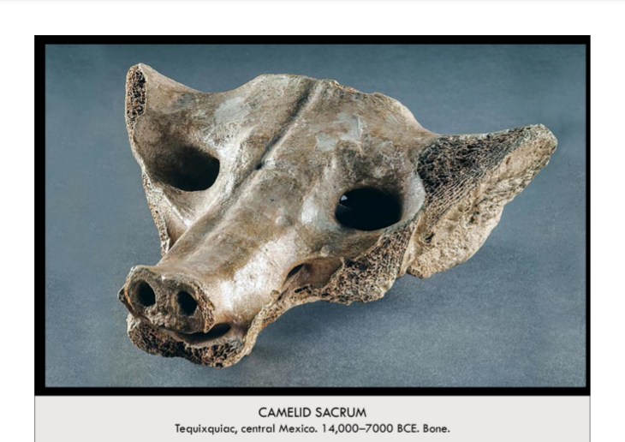

| **Form:** made from the now fossilized remains of the sacrum—the triangular pelvic bone—of a camelid (now extinct), a member of the camelidae family (along with alpacas, llamas, camels)  **Function**: Intended function and original meaning unknown, prehistoric artisans drew/painted/carved/sculpted what they saw in their everyday life. so, choice to render image of a canine makes sense. study and depiction of animals was common in prehistoric art  **Content**: head of a canine- natural shape of sacrum bone probably suggested image of canine to the carver, nostrils, mouth, other details added by carver  **Context**: There is not much known about this work, because: No stratigraphic analysis from site of discovery, so date of creation is difficult to determine, Prehistoric, so no written records of artisan, purpose, meaning, date, etc. Lost to scholars for about 60 years (1895-1956) because it was privately owned during that time. spiritual significance of the sacrum, by looking at later Mesoamerican cultures, which viewed the sacrum as spiritual and sacred, it can be inferred that this sacrum was chosen for similar spiritual reasons. pelvic bone is the fulcrum of the body, and central to internal organs (in particular, reproductive organs) sacrum could be symbol of fertility, or connection to ancestry and posterity. The English word "sacrum" is derived from Latin: "os sacrum," meaning "sacred bone."  **Compare:** uffery, Piso Lua Afe (corned beef 2000), Muybridge, The Horse in Motion, Cotsiogo, Hige Painting of a Sun Dance  **03**  Global Prehistory |
| --- |

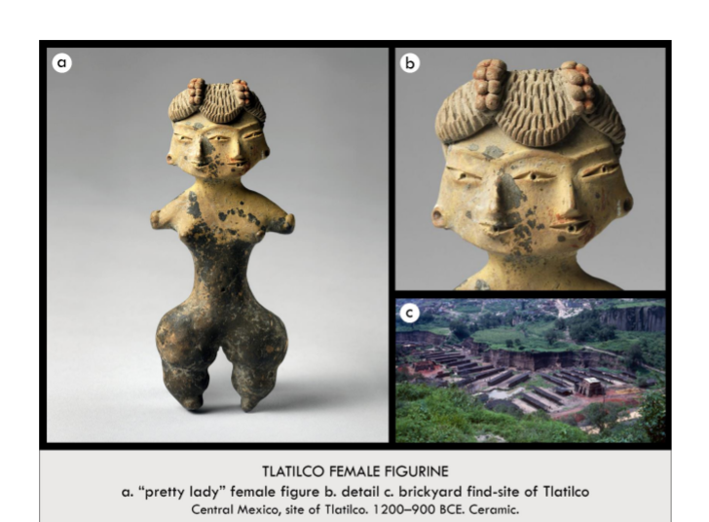

| **Form:** Curved, rounded , Faces blended into one another, "Tally mark" lines indicating texture and shape of hair (possibly alludes to race/ethnicity), Somewhat discolored by time and wear  **Function**: To depict the female figure and signify its importance, Possibly an idol or physical manifestation/representation of a deity  **Content**: Two-faced, one body, Naked (presumably), as no clothes are depicted and the nipples are emphasized, Matching (elaborate) hairstyles  **Context**:Tlatico, c. 1500 - 1200, Creator's identity unknown (possibly because the concept of names was nonexistent)  **Compare**: Veranda post , Power Figure , Reliquary of Sainte-Foy  **10**  Global Prehistory |
| --- |

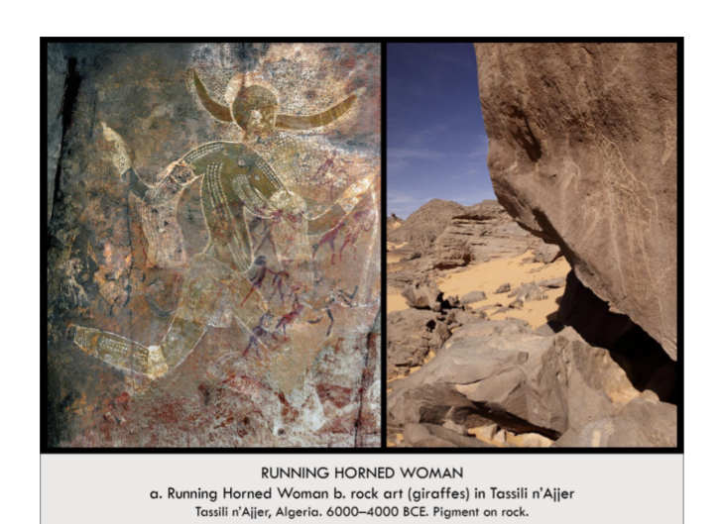

| **Form:** rock art paintings from africa, from algeria.  **Function:** prehistoric african rock painting , unknown, possible ritualistic or a simple depiction of a person of the time.  **Content:** shows a running person, the person has horns, the perspective is twisted the horns are from the front and the persons body is seen from the side, and the person/ women in the image is wearing clothes, arm bands - decorative, and there is fabric. Hair hanging from the bands, she is wearing a skirt, some sort of knee bands, and there are dots/ markings ov er her body, shows body modification and body decoration or the ritual of this image. Could be a hybrid figure of a ritual headdress. Wearing flowing clothing.  **Context:** found in a treasure trove, one of more than 15,000 paintings and engravings found at this site. Sole works are naturalistic, some are abstract. Subjects include livestock (cows, sheep) wildlife(giraffes, lions) and humans ( hunting, harvesting ). The entire site was made by many different groups over a large expanse of time.  **Compare:** hall of bulls, apollo 11 stone.  **04**  Global Prehistory |
| --- |

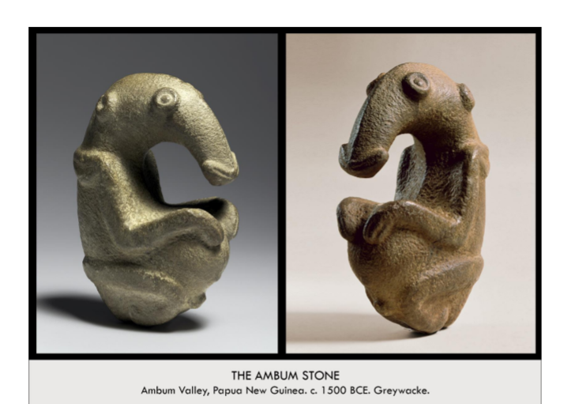

| **Form:** A greywacke stone-carved sculpture. It is about 8 inches high  **Function:** The function is unknown. = prehistoric object  Theories include:  -A representation of a masked human. An anteater in a fetal position (anteaters are significant because of their fat deposits, a desirable trait).  -A pestle for the grinding of food.  -An unknown ritual vessel or altar for the placement of objects.  **Content:** The work depicts a composite human/animal figure; perhaps an anteater head and a human body with a distended belly and alert expression, it is sitting in a criss cross pose with its arms in ground. A representation of an ant eater. Has a curving body with the body of a human and the head of an ant eater.  **Context:** This is a stone age, prehistoric work found in the Ambum Valley in Papua, New Guinea( Melanesia. The unknown artists used stone to carve stone ANt eaters are known for their fat and are a symbol of wealth and food, the rich people are fat because they have access to food.  **Compare:** Prehistoric Animal Figures  *Mexico, Camelid Sacrum*  Human Animal Hybrid Figures:  *Germany, Lion Man of Hohlenstein-Stadel*  **09**  Global Prehistory |
| --- |

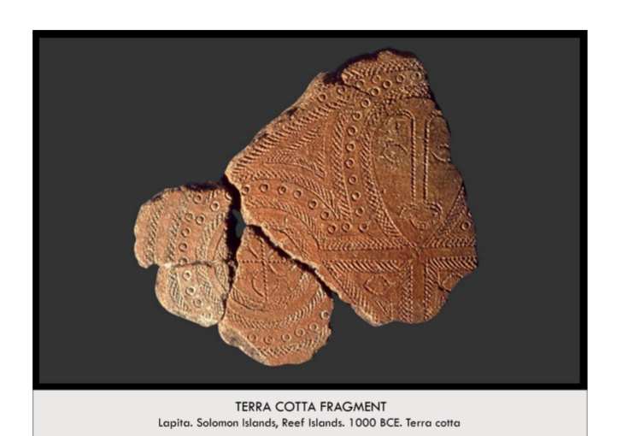

| **Form:** Terra-cotta fragments with stamped imagery  **Function:** The function is unknown.  **Content:** The clay pottery is worked into a smooth flat surface and stamped with curved patterns; dots, circdes, and hatching. The image of a human face perhaps attached to an abstract body is present.  **Context:** This is a work made by the Lapita culture of the Solomon Islands, a place known for its history of pottery production. 1These outlined forms were made using a comb-like tool to stamp designs onto the clay. These fragment samples contain one of che oldest human faces in Oceanic Art (polynesisan)  **Compare:** Human Faces:  *-Africa, Mblo Mask*  *New Zealand, Gotfried Lindauer, Tamati Waka Nene*  *-Byzantine, Icon Painting,*  *- Virgin d Child Between Saints Theodore d&- George*  **11**  Global Prehistory |
| --- |

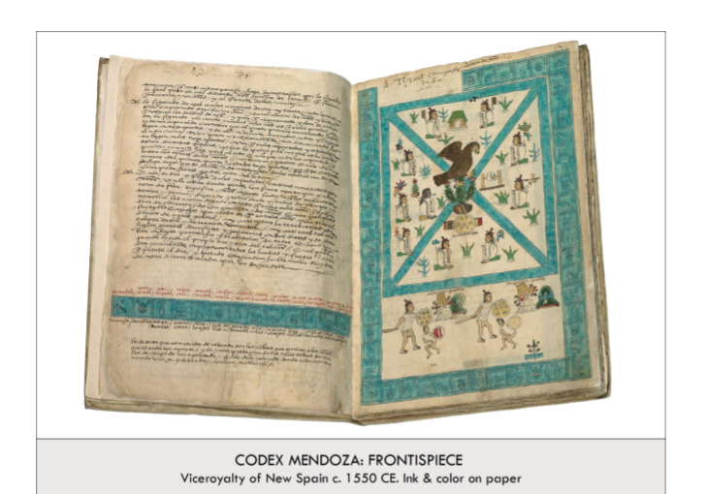

| **Form**: an illustrated book written in Spanish , a frountace piece(opening illustration of a book)  **Function**: intended as a history of the Aztec people for Charles V of the Holy roman empire. Show power/ greatness of their empire, to record history, worship and respect the Gods, and important stories of the founding of city  1541: Antonio de Mendoza (the first viceroy of New Spain) commissioned a codex= to record information about the Aztec empire for him to know  artist(s) were indigenous: images annotated by Spanish priest that could speak Nahuatl (language of the Aztecs)→ sense of the control the story?  **Content**: The Codex: great amount of information about the Aztec empire Frontispiece:  Information about the organization, foundation, origins of the (Tenochtitlan) Aztec capital believed to be four parts aligned with the four cardinal directions (north, east, south, west). Aztec myth: Huitzilopochtli (Hummingbird Left) =patron deity told the Aztecs’ ancestors to leave Aztlan (ancestral home) and find a place with “an eagle atop a cactus growing from a rock” → when they see this they should settle and build city there: saw this sign middle of Lake Texcoco therefore capital was on an island in the lake. an eagle on a cactus growing from the midst of a lake, The eagle and the cactus symbolize the city founding + values. below the cactus + stone: is a war shield= symbolizes Mexica did not settle peacefully in the Valley of Mexico  **Context**: Codex (*Codex Mendoza)=* information about the lords of Tenochtitlan, the tribute paid to the Aztecs, daily life year to year, inner working of the empire . 1541: Antonio de Mendoza (the first viceroy of New Spain) commissioned a codex= to record information about the Aztec empire  **Compare**: Narmer pallet ( Egypt)  **81**  Early Europe & Colonial America |
| --- |

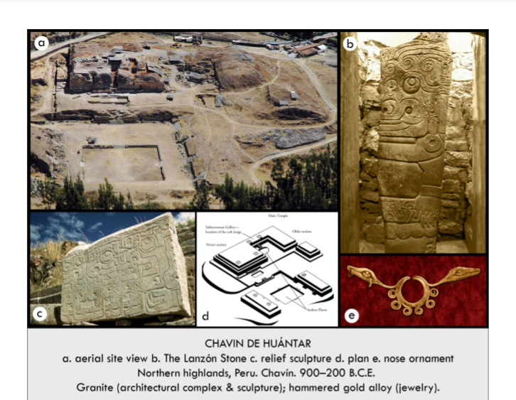

| **Form:** built in a U-shaped plan overlooking a large plaza with an expensive view. created from Granite, hammered gold and alloy, all man made, examples of early architecture.  **Function:** the religious and political capitol of he chavin culture of ancient Peru. Most likely A sight of pilgrimage with stone action as , central religious chample a religouse experience.  **Content:** A series of stepped platformed hol ceremonial buildings including a 60-meter tall temple adored with a jaguar sculpture, a symbol of power. This temple also has a hidden entrance leading to a maze of underground stone corridors witch center in a lingle Lanzon Stone. Multiple stepped plan, gallery. There is a complex tunnel system that leads to the outside and other passages. 3000 year old nose canceling surround sound cathedral.  **Context:** was created in 900-200 B.C.E and was located in current day, Peru Chavin. Created by the Cavin civilization, one of americas first structures created of stone, they are using cut stone- new technologies, a new way to to architecting, one of the first powerful civilizations of The Americas, hundreds of thousands of people would come to visit this area. They would hold ceremonies and play music in these tunnels. They worshiped a deity/ transformed human that was thought be to halt jaguar and half human. Shows the foundation of an government. A prehistoric culture, they didi not have a language  **Compare:** Mecca, the kaaba  **153**  Indigenouse Americas |
| --- |

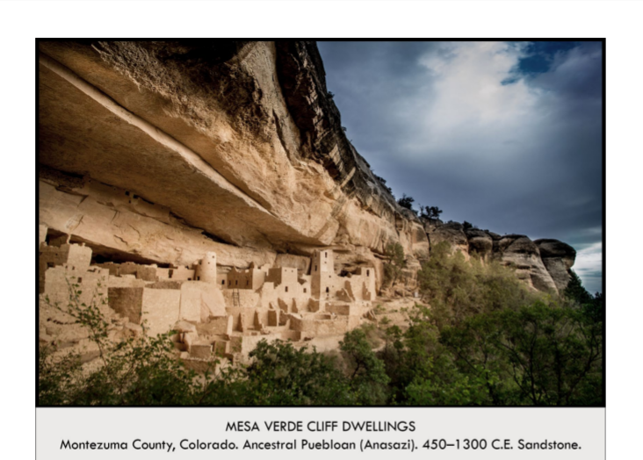

| **Form:** located up on a cliff and build of of stone , made of sandstone. Largest cliff dwelling in north america.  **Function:** as an ancient town, settlement of residence, farming and storage,  **Content:** built into a cliff, for protection, top ledge for each of these kevas os for holding grain, faming done on a plato and water is brought from below. There were buildings for homes, water storage and food storage. Has 150 rooms. Each room is about 6 foot by 8 foot, and they had wooden roofs, there eare some places that might have been used for ceremony 2 or 4 people are thought to have shared each room, there are some images and artwork in the dwelling, they show abstract representation of the surrounding area  **Context:** built by the native americans of the southwest, they would farm over top and they take them down and store them. There wer not many people that could live there. They needed the protection because of clan fighting. Located in Colorado. Built by a civilization of people called the anasazi / ancestral puebloans  **Compare:**  **154**  Indigenouse Americas |
| --- |

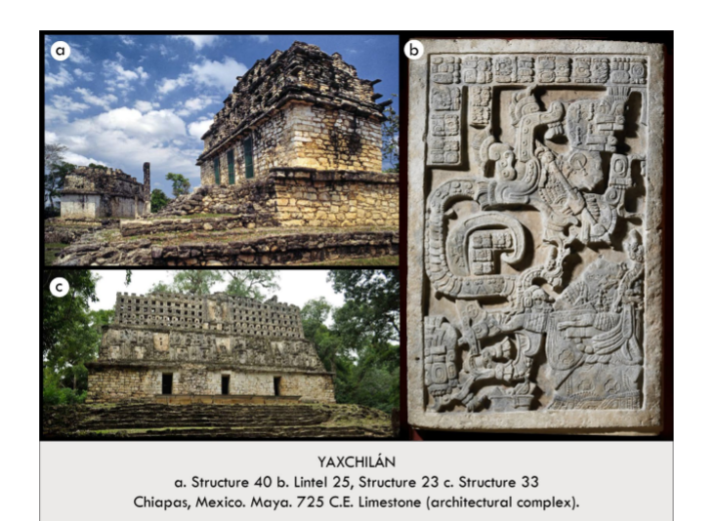

| **Form:** Limestone, this was a high classical for of architecture from Yaxchilan  **Function**: to show the political and religious power of the leader and future leaders Sheild Jaguar and Bird Jagurie  **Content**: has central, south and west acropolis. It is located next to a river, (Usmacinta) b) come roof architecture, pierced honey comb, built by bird jaguar. Building is very narrow and one vault dipa and was not intended for many people, elaborate room comb, there were 3 passages that lead into one room, it has an impressive height. A0 pyramidal type steps, bird jaguar made this as part of his campaign for rulership. 3 doors leading to a central room, interior framed by corbeled arch: stacking stone. B) there are myan hieroglyphics (wrighting) which makes it non- prehistoric , at the bottom is lady zoc and in the hillusiontory stage of blood letting ritual, and did this to commemorate her husband, she is hylisonation girant vision serpent and out of its mouth comes the war god Tlaloc, and the significance is unknown, the work is gorgeous carved in bai-relief. Structure 23 has a lentil that was taken off of ut and all of the structure are very similar, 3 doorways leading to central room and a roof.  **Context**: we known about it because there is writing. The art is  **Compare**: egypt and the maya. Compare to pentanoic freeze on the parthenon.  **155**  Indigenouse Americas |
| --- |

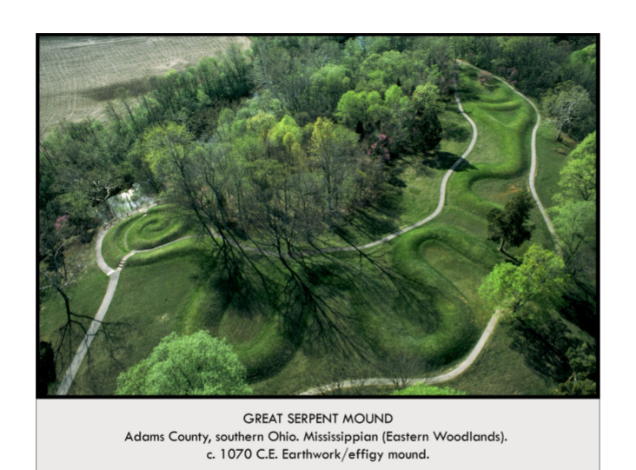

| **Form:**  mound from the mound building cultures of north america  **Function:**  unknown, not graves, ritual, symbolic land work uniting the cultures. Response to the passing of halley's comet, tracing the path they found in the sky, an elegy to the nature, snakes are revered animals, snakes eat rodents and rodents eat food. Snakes are associated with crop stability.  **Content:**  for of the surpend, has an unrelated body with the head of a serpent. It is a curves and qtisted lines that seem to emulate the image of a serpent.  **Context:**  created by the Cshoksi, was built over many years, built for many different parts and then  **Compare:**  spiral jetty, a movement of earth. Connection to th e earth.  **156**  Indigenouse Americas |
| --- |

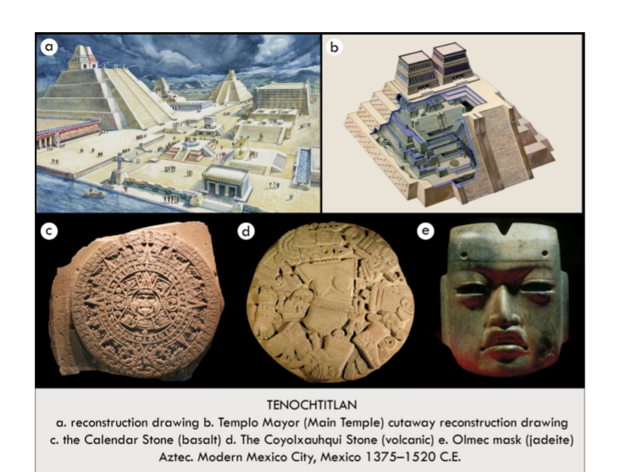

| **Form:** Volcanic stone and covered in stucco , the post classic period and Mesoamerican style. A large symmetrical building with twin staircases leading up to two identical temple towers. Was a focal point of the society and taller than all the other buildings Coyolxauhqui Stone: C. 1500, Volcanic stone, Found in Templo Mayor in 1978, A Monolith relief carving and was originally painted red orange white and blue Olmec-style mask: C. 1200-400 BCE, Small Polished sculpture made of jadeite, Recovered at the site of Templo Mayor, From Olmec culture, before the Aztecs In Gulf coast of mexico→ distant in geography and time  **Function:** the central city of the aztec people, home to more the 150,000 people. As a place of residence, sacrifice and religious ceremonies. A sacrificial stone, Modern day Emblem of mexican culture, Records the origins order and structure of the universe  **Content:** consisted of great pyramids. Created on a island in Lake. Main temple of the Mexica people, Design is inspired by Mexica mythology, Either side of the temple was dedicated to and represented the two primary gods b) Central pyramid in the sacred precinct of Tenochtitlan. Hold destroyed by spanish in 1520 by. At the top is the temple of Tlaloc and Temple of Huiz d) mauve sculpture, wich was placed at the base of the temple C) Massive circular felife sculpture/ alter once holding a flint knife & brilliantly painted placed at the top of the twin pyramids.  **Context:** a culture independent of europe. The europeans thought that the aztec were barbarian.  **Compare:** White Temple and its Ziggurat, emory board  **157**  Indigenouse Americas |
| --- |

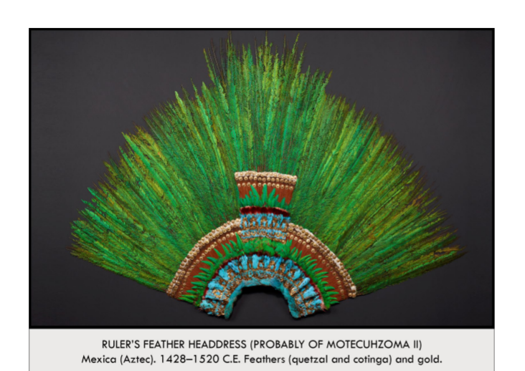

| **Form**: created from fethers and gold. Created very beautifully, Feathers mounted on wooden sticks layered in semi-circles with small plates of gold, Originally included a golden bird beak. Each of the 450 feathers is a tail feather from a different bird, specifically quetzals and contigas  **Function**: a rulers headdress, to show authority and power. Thought to have ceremonial purpose, Was carried on a long stick through town. Performed in as part of a costume. Feathers were a very important part of the Aztec Economy  **Content**: Vibrant colors and rare materials indicate importance and status, Took a long time and much dedication to make, as each feather was retrieved from a different bird. Feathers used in this headdress are from birds located in the Yucatan peninsula, meaning that extensive trade was required to acquire these feathers, Quetzal tail feathers from the male birds, each of which carry only two long tail feathers that are used in the headdress, Made by amantecas (feather workers) who were highly skilled artists and lived in a special quarter of the capital  **Context**: the only surviving rulers headdress from the Aztec Empire. Part of the aztec civilization,w itch was a fully functional clizilivation, witch was separate from europe and had their own governments, cultures and religion.  **Compare**: Feathered cape of Hawaii  **158**  Indigenouse Americas |
| --- |

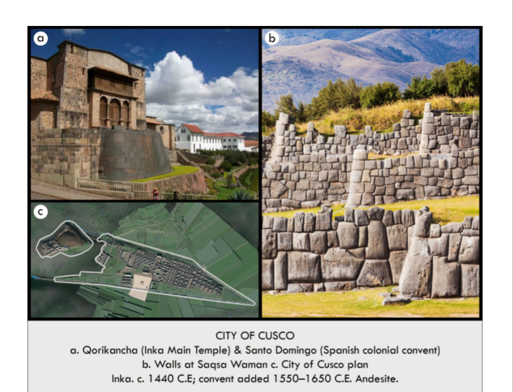

| **Form:** they were known for their brilliant ashlar masonry ( they were amazing at cutting and fitting stones together. Red roofs, Buildings are close together, The city was built on a flat valley that is surrounded by a mountain range –– ideal place for a settlement, Fertile land, Fed by several rivers, Extremely organized, Technical stone constructions, Urban layout  **Function:** capital city of the Incan empire, home to mor than 150,00 people. A0 temple of sun, spanish built a catholic church on top. Stones of temple example of ashlar masonry. Capital of Tawantinsuyu (“Land of the Four Quarters,” name for the Inca empire in Quechua) Divided into four quarters that represent the four divisions of the empire  **Content:** in the shape of a puma witch was sacred aminal. a) most important temple, functioned a an obersitory and was originally covers din gold. b) ashlar masonry= good example, stones taken from quarry 2 miles away. City is thought to be laid out like a puma (symbol of strength) The stone construction shows the advanced ability of the society with aesthetic values and structures. The nobles’ houses were separated from the rest of the city The architecture and urban layout solidified the city’s importance as a political power  **Context:**  a civilization of millions of people. 15th century–– the city was redesigned and remodeled after a pre-Inca occupation, Inca Empire, Did not have many features associated with old world (wheel, animals to ride and pull plows, knowledge of iron and steel, written system) Known for monumental architecture, extensive road network, textiles, use of *quipu* (knots) for record keeping and communication, agricultural accomplishments (especially in the harsh environment), and their political structure Did not have a money system  **Compare:**  **159**  Indigenouse Americas |
| --- |

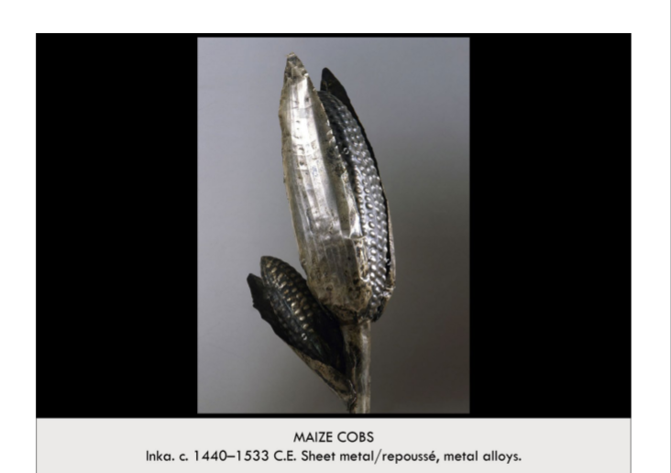

| **Form:** Inka metalsmiths combined silver and copper to mimic the internal and external components of actual corn. The Maize cob was made out of a mixture of copper and silver by Inka metalsmiths, It was made so that it retained the lifelike proportions of actual corn, and was thinner on the husk and thicker on the actual corn, The Maize cobs kernels were individually sculpted so that they are still visible, just like on actual corn  **Function**: example of Incan metalwork, maybe placed in the corn to celebrate grown and to represent prosperity. The Maize cob was supposed to be a ritual offering performed by the Inca government or state religious officials. Many gold and silver objects as well as some textiles were used as offerings and sacrifices in the Inka religion, The rituals and offerings help retain Inka offical’s power (the Qorikancha’s garden reinforced the Inka’s divine right to rule) All these offerings acted as symbols of the supernatural origin of the Inka’s in the Sun, and their control over the natural world as descendants from the most powerful deity  **Content**: sheets of an alloy of sliver and gold has been fashioned using repose hammering techniques into the shape of two corn cobs. A life sized metal corn cob sculpture made of silver and gold. Mimics the appearance of ripe corn ready to be harvested, Sculptural representation of Zae mays. Corn was a very important part of life, honoring the corn  **Context**: the Incan Metalwork. Maize was the principal food source od the Andes(incas) civilization. Displayed in a metal garden in the courtyard of one of the most important Inka temples, the Qorikancha, in the capital city of Cuzco. Inka art (unlike many other Andean artistic traditions) favored naturalistic forms, as seen in this life like portrayal of corn. European invaders desired the gold and silver the Inkas had. Some of the earliest Spanish chroniclers record the placement of a garden composed of gold and silver objects among many of the offering and ritual spaces in the Qorikancha (including similar sculptures of the corn) Plants and animals represented in the golden garden cannot grow and survive at every point in the empire, but only at certain altitudes. Maize grows up to a mid-range altitude, metallic maize cobs would have represented one of the most important imperial foodstuffs, used for making the chicha (maize beer) consumed at feasts  **Compare:**  **160**  Indigenouse Americas |
| --- |

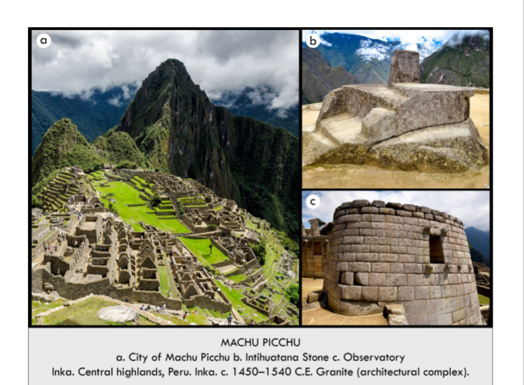

| **Form:** very beautiful. Surrounded by mountains. Ruins of an Inca city, Located near the Inca capital (Cusco), Composed of houses & terraces built by fitting individually carved stones together. Made up of a stone enclosure with windows above a cave structure  **Function:** an Incan city built on an remote site as a royal retreat of the 15th century ncan rulers & elit citizens. Emperor was very spiritually engaged and was the spiritual leader of his people- performed rituals relating to supernatural forces at this site The Intihuatana or a carved boulder (“hitching post of the sun”)- used sun and shadows to tell the time (religious rituals were very time oriented) Used for astronomy and studying the sky- people went to the high points of the building. Area where the elite could gather- plan the fate of the empire, have feasts, and perform religious acts.  **Content:** contains baths and obersitorys. There is asher masonry. Main building construction = typical Inca elite architecture (Stones shaped to fit one another, not to look uniform) Buildings & layout highlight social divisions, Structures for people of lower class were made more crudely & not in the typical Inca elite style. The observatory is next to his residence, drawing connections between status, royal authority, ritual, and astronomy. Machu Picchu contains many religious structures  **Context:** they were skt readers and they valued their observatories, it would be dark and they would look into the sky. Originally used as a palace for Inca emperors- Pachacuti Inca Yupanqui- mid 15th century. Overlooks the Urubamba river (near modern day Peru) near Inca capital of Cusco, and nearly 3,000 feet lower in elevation. In a fertile climate, Chosen because of its proximity to Adean landscape- sight lines to other mountains “apus”  **Compare:** Stonehenge  **161**  Indigenouse Americas |
| --- |

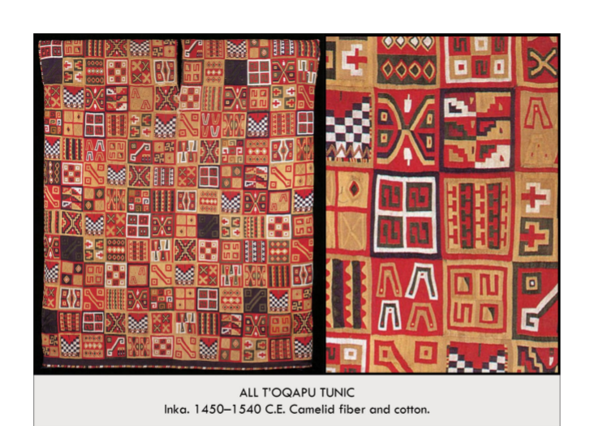

| **Form:** An incan tunic, created from dyed Camelid fiber. Tunic: A woven rectangle piece of cloth folded to be a square, with a slit woven into the middle for the neck, decorated with small red woven squares. T’oqapu: composition of these square geometric motifs that make up the entirety of the tunic, found around stomach or shoulders on upper class tunics.Normally, an Inka tunic with t’oqapu on it would have a band or bands of the motif near the neck or at the waist. The All-T’oqapu Tunic is made of dyed camelid wool warp over a cotton weft, which was a common combination for high-status textiles.  **Function:** may have been biogragical, and indicated a high status for the wearer. A tunic worn over the body and sewn up under the arms, by an elite member of society. Worn by the king (Sapa Inca) to identify him and keep him warm Tunics like these served as power symbols in the Incan culture with each small insignia, or T’oqapu, representing an accomplishment or history of an individual. The mass of T’oqapu on this tunic ensure to us that it belonged to a royal. Believed the cloth had spirit (camuc) Textiles were also used for maps, quipu (bookkeeping or like numerical storage device)  **Content:** From individual rectangle-shaped T’oqapu. The garment exhibits the Incan Preference for abstract design neatly ordered to create a striking pattern. The *All-T’oqapu Tunic* created during the height of Andean textile fabrication==Direct link to Inka’s value of power. Name derives from how the tunic is decorated. Each geometric square displays a unique motif that combines together to make up the whole tunic.  **Context:** Each may be symbolic of individuals, events, or place. Indicated high status. And example of an Incan garment. The Inka were masters of statecraft. Forged an empire that at its height extended from modern Quito, Ecuador to Santiago, Chile. One of the engines that drove the empire was the exchange of high-status goods  **Compare:**  **162**  Indigenouse Americas |
| --- |

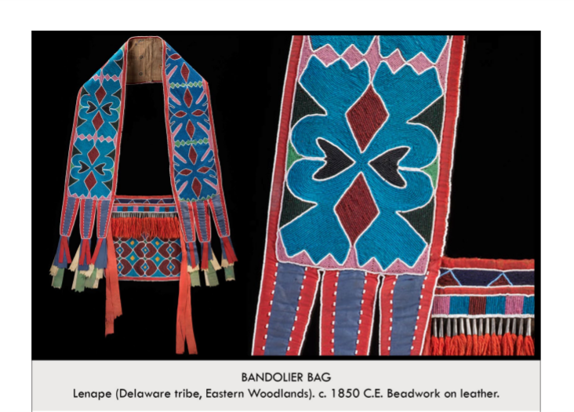

| **Form:** beaded bag created by the lenape people. Bandolier: Red trimming around entire cloth and tassels at the end, Floral blue, black, green, and pink pattern on cloth, Ends of the bandolier have trapezoidal extensions which end in green, red, tan, and blue tassels, The bandolier is a long rectangle, would reach below the waist (but likely not to the knees) Only one side of the bandolier is decorated → the other side is brown  **Function:** is worn by people over their shoulders, a bag for holding things. Bandolier bag is worn as a cross-body bag → a strap crosses the chest and allows the bag to rest on the hip Bags were commonly decorative → even those with pockets were not necessarily used to hold anything, Men could wear more than one bag at a time Express group identities and social status Especially in the face of displacement → represent the determination and perseverance of Lenape people and Lenape culture  **Content:** contain geometric, abstract designs made of bead. There are thousands of beads strung together across the bandolier bag’s surface. Based on bags carried by European soldiers that held ammunition for rifles, Large in size, Trade cloth (cotton, wool) and hide are used as the base for the bags and straps, Seed beads (tiny glass beads) are acquired from trading with Europeans  **Context:** from tribes in the great plains. Made across tribes in Great Lakes and Prairie regions, Styles depend on tribe and on contact with Europeans (for materials) Bandolier bags especially popular in Woodlands region (Great Lakes and territory East of Mississippi) in nineteenth century. Women created the bags, while mostly men wore them  **Compare:**  **163**  Indigenouse Americas |
| --- |

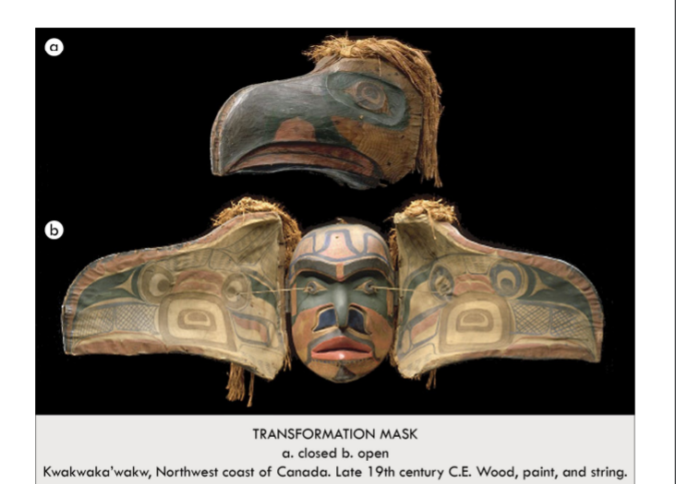

| **Form:** eagle transformation masks. Created of wood, paint and string. Large, exaggerated bird head, Large beak. Opens to show a human face, Multiple bright colors, Hair made of string  **Function:** performance mask made by the Kwakiutl peoples of the northwest coast of Canada. Creates a powerful effect during ceremonies. Worn during potlatch where the host displays his status, Conveyed a high social status. Portrayed family genealogy–– could contain family crests. Passed between family members of a clan  **Content:** was originally brightly colored.mask is intended. In the shape of an eagle, Pull chords and the mask opens, The open form seems like a bird spreading its wings, The human face is of an ancestor, Uses elements of formline style  **Context:** this is theater for native americans, very inventive, only culture to create. Mask worn during dance ceremonies. Dancers open the mask while dancing, Masks takes months to years to make. Carving techniques changed after tools introduced by Europeans etc. and brighter synthetic colors were also introduced. Transformation masks were an integral part of the culture and existed in multiple forms. Masks were worn with a cloak made of red cedar bark  **Compare:** elephant mask in africa, and maks of oceania.  **164**  Indigenouse Americas |
| --- |

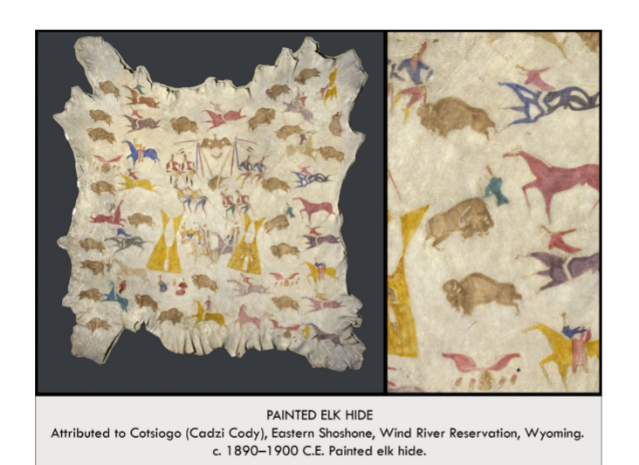

| **Form:** painted elk-hide. Pigment used on elk hide, Animal painting tradition used to record history, Combination of free-hand penciling and using a stencil  **Function**: ceremonially worn as a robe over the shoulders of a warrior. - Multifunctional, working for both the economic and cultural benefit of the Wind River Reservation, Led to economic development because it created sales from white visitors and also led them to attend Sun and Wolf dances, in which they would also spend money. Important as a cultural survival statement for the tribe, as it helped move the once antiquated and ancient tribe artwork into the modern world by making it increasingly contemporary  **Content**: the hide depicts traditional aspects of the Plains people culture there were nostalgic. Combines contemporary tradition to the historical record of tribes. Displays important ritualistic Sun Dance and Wolf Dance  **Context**: painting on animal hides is a long-lasting tradition in the Great-Basin region of the U.S., functioned to preserve history, similar to the oral tradition of story-telling. Animals such as horses and buffalo on the painting were especially important to livelihood, as Buffalo was a source of food and horses were used during hunting.  **Compare:** hunting figures of prehistory  **165**  Indigenouse Americas |
| --- |

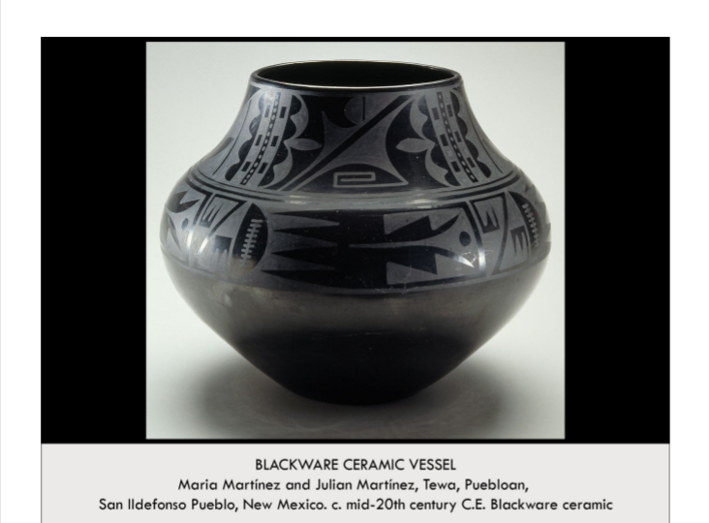

| **Form:** black terracotta with a black graze, Ceramic, mixed with volcanic ash to make it black. pot made by building up coils, not shaped on a wheel.  **Function:** example fo black on black pottery technique created by the artists in the mid-twentieth century. Maria Martínez and Julian Martínez's pieces became known as fine art and were purchased from them as such. Historically, *ollas* and similar dishes held water, stored seed and grain, and were used for cooking.  **Content:** made with exceptionally thin, even walls. The glaze and black terra cotta contrast matte. Images on the pots were often based on natural phenomenon, such as rain clouds, bird feathers, rows of planted corn, and the flow of rivers.  **Context:** showed you could make money with native artist, and with traditional forms. Although women did not have official religious/ceremonial roles and authority, Puebloan rituals centered on mimicking female reproductive ability, and women were afforded respect in the domestic sphere.  **Compare:** Bushel with Ibex motifs, Staff god/ god stick  **166**  Indigenouse Americas |
| --- |

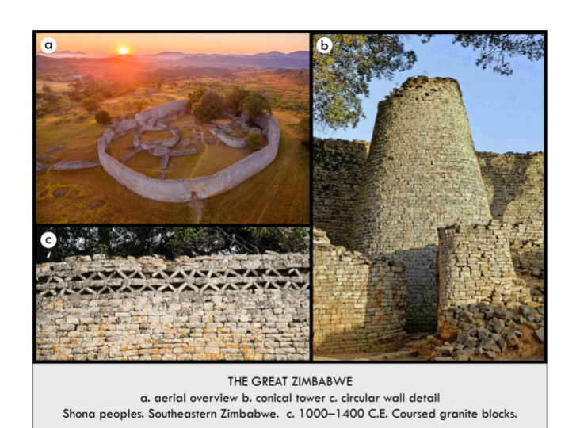

| **Form:** build of coursed granite bricks. An unusual stone complex- most african cultures eschew stone in building and in sculpture, built in the 14th century as a prosperous trading center and probable royal comlex  **Function**: a proporuse trading area and a royal complex,  **Content**: the granite walls are 800’ long 32’ tall, and 17’ thick at their base. They slope inward. The sight contains an iconic conical tower built in the shape of a grain silo. The site also features internal and external narrow passages which mut be passed single file. This mimics the walking patterns in the African brush  **Context**: zimbabwe means stone house and is named after these buildings. An unusual complex equate the use of stone. The symbolic control over food connotes wealth, power and royal largesse in african culture  **Compare**: agora in ancient greece, tajens forem.  **167**  Africa |
| --- |

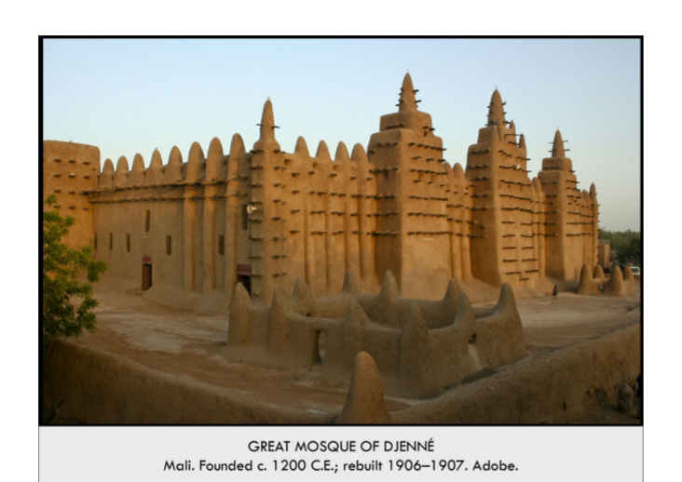

| **Form:** first built 1200 CE and remodeled in 1907. Walls made of adobe( mud, straw) ( measuring 85’by164’)  **Function:** islamic mosaic on the house plan, which came out of Mecca,  **Content:** projecting from the walls are wooden beams called Torons witch act as ladders for the building’s maintenance. The building features 3 tall towers topped with ostrich egg ornaments, symbols of fertility & purity. The central tower is the mihrab( the wall niche location along the qibla wall painting to mecca which worshippers face to prey.  **Context:** African and islamic art. Largest mud-brick building in the world  **Compare:**  **168**  Africa |
| --- |

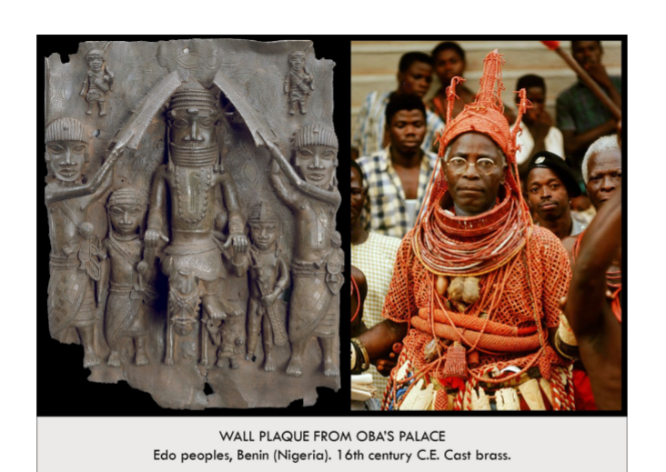

| **Form:** a bronze relief sculpture wall plaque.  **Function:** created for the walls pf the Oba’s palace , the royal palace in Benin  **Content:** Imagery incudes the Oba, riding a donkey and sleeping on the enemy, being shielded by servants. This is a symbolic depiction of victory. The Oba is hierarchically larger then his servants and much larger then his defeated rival.  **Context:** one of the 900 plaques using the lost-wax technique over many decades celebrating the dynastic Oba’s(king’s) of Benin who were believed to be direct Descendants of Oranmiyan, the legendary founder of the dynasty.  **Compare:** pallet of narmer, hierarchy of scale and leader defeating his enemy  **169**  Africa |
| --- |

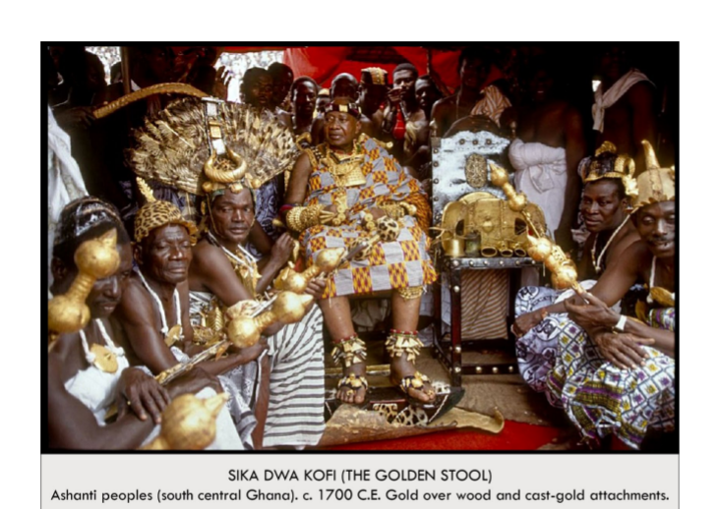

| **Form:** A wooden stool covered in gold.  **Function:** This object is the symbol of the Ashanti nation in Ghana. It is more important than any king or ruler of the Ashanti and is never used as a stool. It is only taken out on very special occasions. It must never touch the ground and is placed on its own stool or chair. New Ashanti kings are raised over the stool. It is often carried to the king on a pillow. Only he may touch it.  **Content**: The actual stool has many replicas, but each replica is different. The seat is flat and held by abstract posts, two of witch are ornamented with sun-like flares. It rests on a flat base. Bells hang from the underside of the stool. The entire surface is covered in smoothed gold. Gold is the color of the supernatural and spiritual realm. This is an  other-worldly object.  **Context**: This is an African ceremonial object that the first king of the Ashanti claimed fell from the sky. It literally contains the soul of the nation of the Ashanti. In 1900, a British representative tried to sit on the stool which caused and uproar & a rebellion of the Ashanti people. The war ended with Ashanti independence from the British annexation of Ghana.  **Compare**: Sacred Royal Objects; Silla Period Korea, Gold d Jade Crown  **170**  Africa |
| --- |

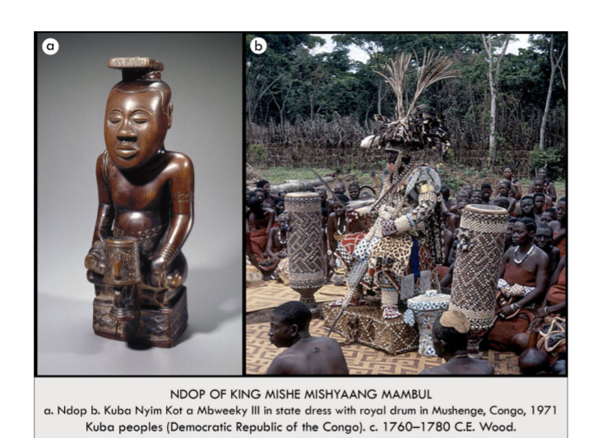

| **Form:**  An oil rubbed wooden sculpture- one of the earliest wooden sculptures in Africa.  **Function:**  shine element for a decided ings, as a shrink for the dead king, and they are all similar with a different symbol to identify.  **Content:**  an idealized representation of the king that is idealized, the king is in an ideal state, cross legged on a throne base,closed eyed and distant, and he is holding a peace knife in the left hand, with an b) reference photography  **Context:**  The Ndop is made after the death of the king.  **Compare:**  Houdon, *george washington*. Lindauer, Tamati Waka Nene  **171**  Africa |
| --- |

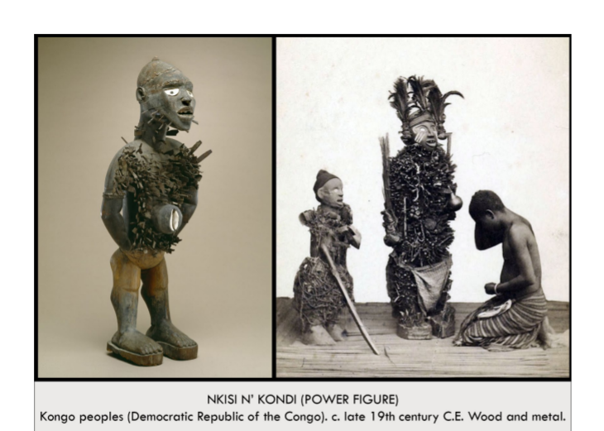

| **Form:** A wood shell, And metal sculpture, a power figure and interactive sculpture  **Function**: Nkisi N'Kondi figures are interactive spirit effigies( depiction of something. Supplicants(someone who needs something) call upon the spirit in the figure to bless or harm others, cause death, or give life. In order to prod the image into action, nails & blades are inserted or removed from the figure. Medicinal combinations called bilongo are sometimes stored in the head of the figure but frequency in the belly of the figure which is shielded by a piece of glass, shell, mirror or other reflective surface. This area represents the realm of the spirit. Seeds inserted tell a spirit to replicate itself; Claws incite the spirit to grasp something while stones activate the spirit to pelt enemies or protect one from being pelted. ( depending what you give you are asking something from it)  **Content**: The work depicts an abstract standing male figure with an alert pose and wide- open eyes. Metal nails and blades protrude from its body and face. A shell is attached to the belly-button region of the body. Wearing some kind of platforms (kind of like shoes) it is most likely ver heavy  **Context**: This is an African power sculpture made by the people of the Congo river  basin region.  **Compare**: Ritual Interactive Statues; Romanesque Period, *Ritugem Pietà*  **172**  Africa |
| --- |

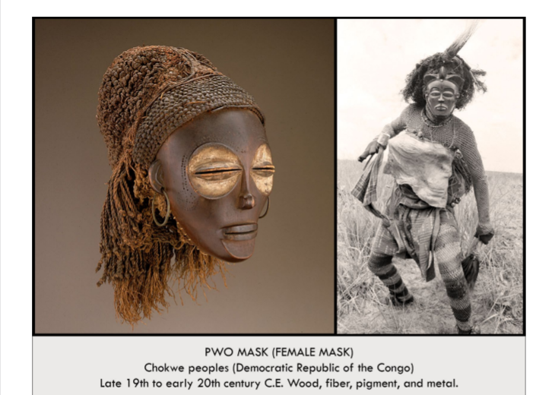

| **Form:** A wood, fiber, pigment, and metal mask  **Function:** These masks are worn by Chokwe men during ritual dances in which men behave like women.  **Content:** The mask depicts a closed-eyed, tight-lipped woman wearing stylized hair and earrings. This is an image of tranquility and ideal beauty. Other characteristics include enlarged white eye sockets, a pushed-in chin, a slender nose, a high forehead, and balanced features.  **Context:** The Chokwe are an African matriarchal society. Male dancers cover their identities, dress as women with braided hair, and masquerade in these masks. When not in use the mask is discarded. Many are buried with the dancer.  **Compare:** Faces in Sculpture:  -New Kingdom Egypt: Queen Nefertiti  -Roman; But of a Roman Patrician  **173**  Africa |
| --- |

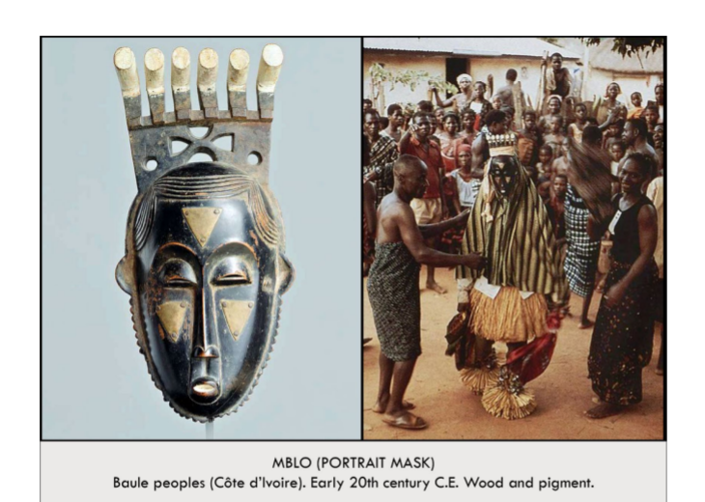

| **Form:** A wood and pigment mask  **Function:** These masks are worn by Baule dancers during Mblo performances  in which an individual is honored with dancing & tributes in their  honor.  **Content:** The mask depicts an individual. It is not a likeness portrait but the idealized representation of a specific person being honored. There is a broad forehead, pronounced eye sockets, a column shaped slender nose. The face is quiet and introspective. This is a peaceful, meditative portrait. The face also shows marks indicating makeup or scarification.  **Context:** These masks are commissioned by groups of admires in the Baule culture to honor an individual. The honoree attends a masquerade and often accompanies a dancer who dresses like them and wears mask in their honor. The honoree receives this mask at the end of the celebration as a gift.  **Compare:**  Art as Gift;  *Fiji; Presentation of Fijian mats and tapa cloths to Queen Elizabeth*  **174**  Africa |
| --- |

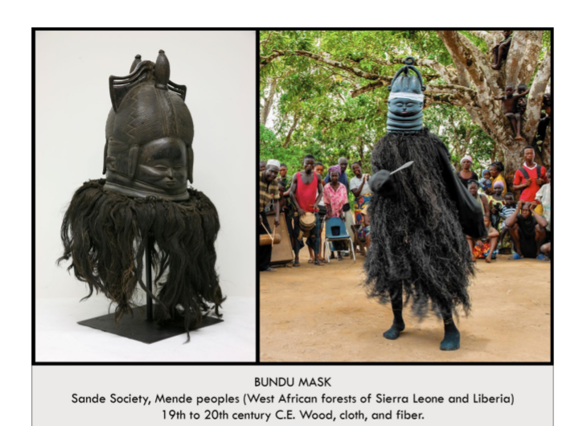

| **Form:** A palm-oil coated wooden, doch, and fiber mask.  **Function:** The mask is worn by a girl-and performed in - during a masquerade in which she ritually transitions into her adult role as a woman in society  **Content:** The wooden mask is an abstract representation of the water spirit Sowei-a figure of idealized beauty. The mask rests on the head of the wearer and the raffia hair covers her face. The dancer additionally wears a black gown of raffia cloth. Black color symbolizes water, coolness, and humanity. The effect of this head rising from it's concentric neck rings is one of Sowei emerging from rippled water. The mask is coated with palm oil to add a lustrous effect. The elaborate hairstyle is a symbol of wealth. The closed eyes represent tranquility. The tight-lipped mouth symbolizes personal control: secrets not revealed.  **Context:** This is the only African wooden mask worn by women. It is part of the Sande Society of the Mende people. The Sande is a group of women who prepare girls for adulthood and their role in society.  **Compare:** Performance Art Making  -Kwakiutl (Native Americans), Transformation Mask  Torres Straight (Micronesia), Buk Mask  **175**  Africa |
| --- |

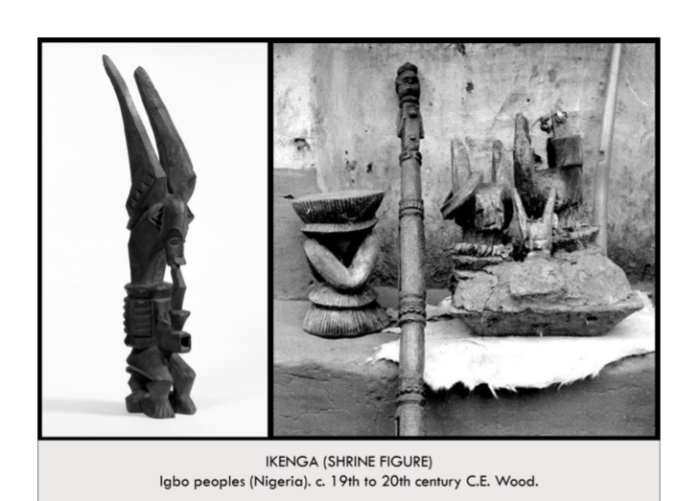

| **Form:** A carved hardwood sculpture, interactive sculpture for a home alter.  **Function**: This objects is an Ikenga (strong right arm): a figure created for the household shrine of a successful man( and occasionally women) as a personal god representing their physical strength, potency & prowess. It further tells owners’s morality, achievements, genealogy, and social rank. Ikenga are kept or owned by people of high reputation and integrity in their society. It comprises someone's Chi (personal god), his Ndichie (ancestors), aka Ikenga (right hand), ike (power) and serves as a vessel of spiritual activation through prayer and sacrifice.  **Content**: The sculpture is an abstract sitting male figure carved from hardwood which is considered masculine. Enormous horns symbolize power. A prominent right arm holds an abstract elephant tusk denoting this as a Warrior Ikenga.  **Context**: This is a prized African object of the Igbo peoples. Ikenga are maintained in the owner's home and are regularly blessed & consecrated with offerings at home shrines before kinsmen. As a man (or woman) achieved more success they might commission a more elaborate version. When the owner dies, the figure is most-often destroyed.  **Compare**: Personal Objects Shewing Status & Achievement  **176**  Africa |
| --- |

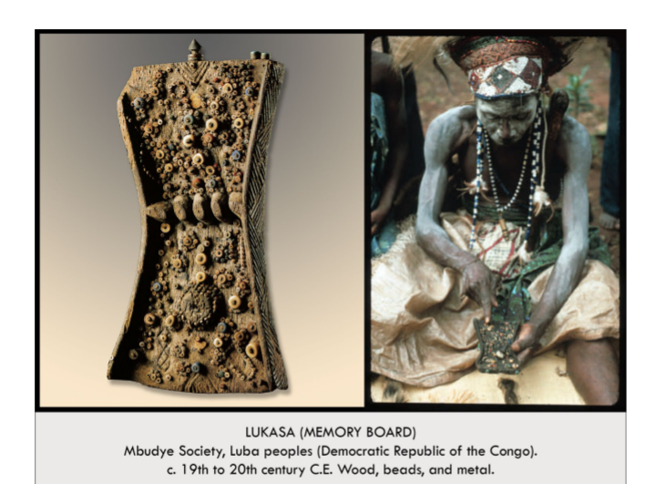

| **Form:** A wood, bead, & metal  **Function:** Lukasa Memory Boards are used by storytellers as memory aids during the performance of their tales. The board depicts key clements in their stories with beads and symbols.  **Content:** The board is carved from a single piece of wood into an hourglass shape. T he back resembles a tortoise. Colored beads symbolize individuals, surrounded large beads represent a king and his court. Lines of beads symbolize a journey. interactive sculpture. Zoomorphic elements include crocodiles and other animals. Abstract marks represent the landscape.  **Context:** Memory Boards are controlled by the Mbudye, a council of men and women who interpret the political and historical aspects of Laba society. The ability to read the board is limited to very few people. The boards are used to convey tales of migration, heroes, kinship, genealogy, and lists of kings.  **Compare:** Functional Art: Marshall Islands; Navigation Chart  **177**  Africa |
| --- |

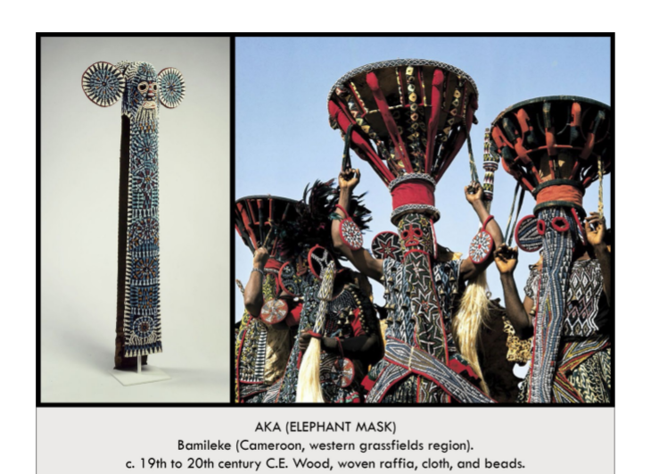

| **Form:**  A raffia-cloth, wood, and beaded mask.  **Function**:  The masks are worn bu elite Bamileke citizens. The mask is fitted over their heads & hangs down their bodies. The wearer performs in this mask during important ceremonial occasions. The wearer dances barefoot to a drum and gong while waving spears and horsetails during this masquerade.  **Content:**  abstract beadwork. The work is an abstract representation of an elephant (long trunk, oversize round cars) with a human face. The surface is covered with beadwork, a symbol of power in this culture.  **Context:**  This is an African performance mask made for elite members of the Bamileke people which they will wear & perform in during ceremonial occasions at their royal court.  **Compare:**  Beadwork a a Symbol of Prestige: *Lenape (Native Americans), Bandolier Bag*  178  Africa |
| --- |

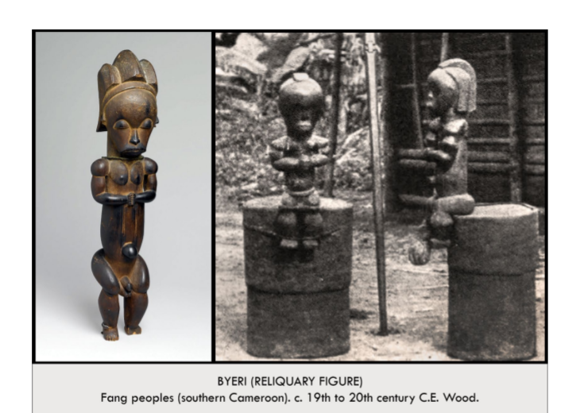

| **Form**: An oil-rubbed wooden sculpture. Made by the Fang peoples  **Function**: Bieri figures are placed on cylinder-like bark box reliquaries as guardians that protect the contents (skulls & bones of important clan leaders) against the gaze of women & young boys.  **Content**: The work depicts an abstract nude male figure with stylized hair, prominent genitals and belly button, a large head, closed eyes, & small arms and legs. These are characteristics prized by the Fang people: Closed eyes represent tranquility & introspection. The prominent genital and belly button emphasize life while the prayerful gesture and somber look emphasizes death.  **Context**: This is an African guardian sculpture made by the Fang people. It is ritually rubbed with oils to protect it from insects and enhance its luster  **Compare**: Nude Male Figures: Donatello, David, Polykleitos, Doryphoros  Guardian Figures: Japan, Nio Guardian Figures, Todaiji Temple; China, The Terra-Cona Warrior, Tomb of Qin-Shi Huangdi  **179**  Africa |
| --- |

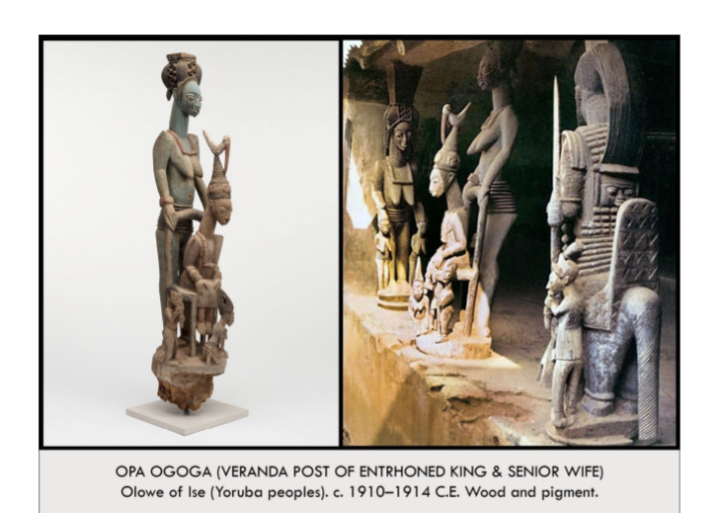

| **Form:** A carved and painted wooden muli-figure sculpture  **Function:** This object once decorated the top of a veranda post in the palace of the king in Ikere located in Yorubaland in Nigeria  **Content:** The beautifully carved and painted sculpture is a depiction of the king of Yorubaland shown siting, his senior wife standing behind the throne, a junior wife below him, and the trickster-god Esu playing the flute also below him. The carving makes generous use of negative space between the figures which is the innovative hallmark of the sculptor Olowe of Ise.  **Context**: he was the most celebrated sculptor of the 20th century. This is an African sculpture. It is one of four veranda post tops that were carved for the palace at Ikere in Nigeria. They were made by Olowe of Ise, most famous Yoruba sculptor of the early 20th century. Kings and aristocrats throughout Yorubaland employed Olowe to carve reliefs, masks, bowls, & veranda posts for them.  **Compare**: Multi-Figure Sculptural Works; Rodin, The Burghers of Calais; Bernini, The Ecstasy of Saint Teresa  **180**  Africa |
| --- |

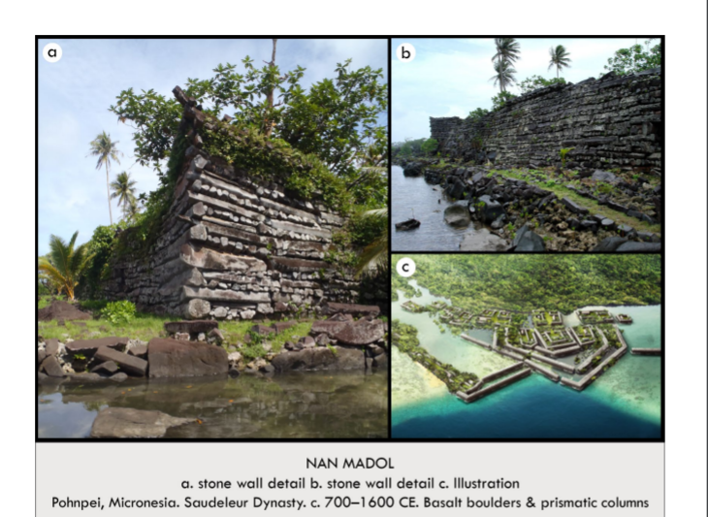

| **Form:** Ancient city that was the capital of the Saudeleur Dynasty ofMicronesia  **Function:** a) act as breaks to control the surrounding Sea and channel the water into canals for flushing Purposes. A sea bound city.  **Content**: 92 small artificial islands are built out into The waterofa lagoon. They are surrounded by And connected to one another by canals in an area of 170 acres. The stone walls of the city are 15 high and 35 thick.  **Context:** This city, similar to Venice or Tenochtitlan in construction, haš its islands built and arranged from southwest to northeast us takes Advantage of the trade winds blowing through. The city ij Arranged to separate the lower and upper classes with the latter clustered Near the king as a method of surveillance over their activities  **Compare:**  Cities on Water   * Medieval Europe Venice, italy * Aztec Empire, Tenochtitlan   Roal Stone Compounds   * Africa, The Great Zimbabwe * China, The Forbidden City * France, The Palace af Versajlles   **213**  The Pacific |
| --- |

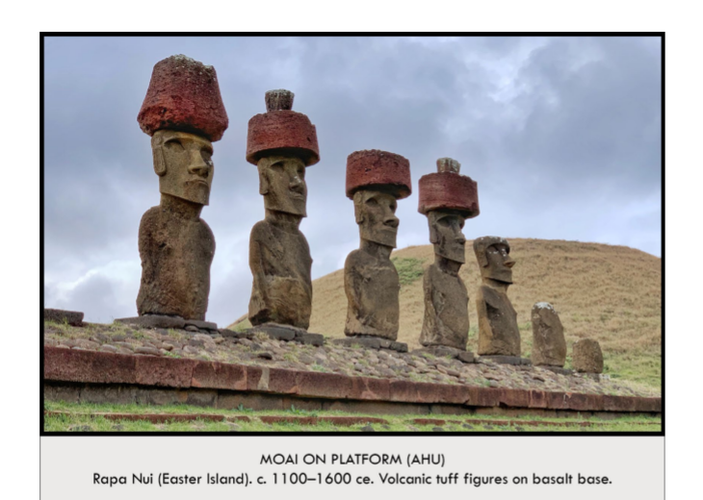

| **Form:** Massive volcanic stone-carved sculptures on an ash/basalt platform  **Function:** The function is unknown. Scholars believe that lineage chiefs or their sons erected the Moai & the sculptures depict ancestral chiefs. They stand on platforms marking burials or ceremonial sites, The people of Rapa Nui created these  **Content:** Archaeologists have documented nearly 1000 Moai erected on 250 platforms called Ahu. Most of the Moai stone is soft volcanic tuff, some are basalt. Individual Moai can reach as high as 50’ and weigh as much as 100 tons. The basalt stone Ahu platform is ofiénabed with the asbes of the dead and are considered as sacred s the figure A number of the called a puka. They all face inland and not to the sea.  **Context:** These iconic works ane the largest sculptures found in Oceania That mysteriously speak of a culture that disappeared due to environmental collapse at the end of the 17 century According o oneeholar. it would have taken 30 men one year to carve a möai, 90 men two/months to transport it from the quarry, and 90 men three months to position it vertically on the platform  **Compare:** Public Statues of Great Leader:  *U.S.A, Houdon, George Washington*  China, Empres Wa as the Vairocana Buddba, longmen caves  **214**  The Pacific |
| --- |

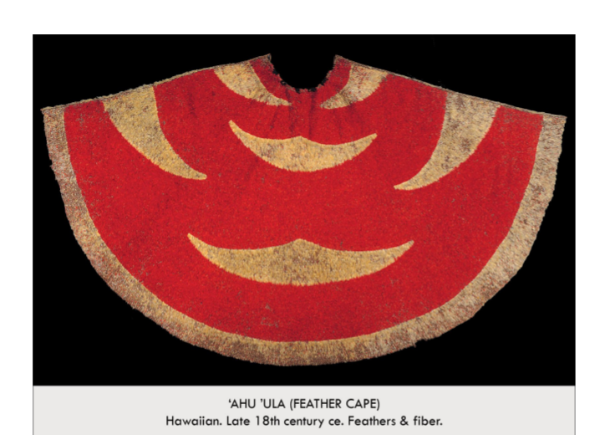

| **Form:** A feather & coconut fiber cape  **Function:** This is a royal garment worn by gaetr of high rank lish ng them to the gods and conferring on them spiritual & physical protection  **Content:** The work consists of over 500,000 feathers pulled from the T "iwi, 'apapane 'o 'o, & (now extinct) Mamo birds. Some of these birds yield only 6 usable feathers. The base of the garment is made from densely planted coconut fibers. Each feather is hand-tied onto it  **Context:** In Polynesian society Chief's real face were prominent part of artistic production. The materials in this doak áre etecmey, precious. Red & yellow are the colors of royalty. The cloak links të owner to the godsDuring the production of the cape, makers chant the names of the owner s ancestors, believing that the power of the sacred chants will permeate the fabric lining This imbues the cape conferring spiritual protection.  **Compare:** Regalia  *-Aztec Empire, Feathered Headdress*  *-Korea, Silla Kingdom Golle Jade Groin*  **215**  The Pacific |
| --- |

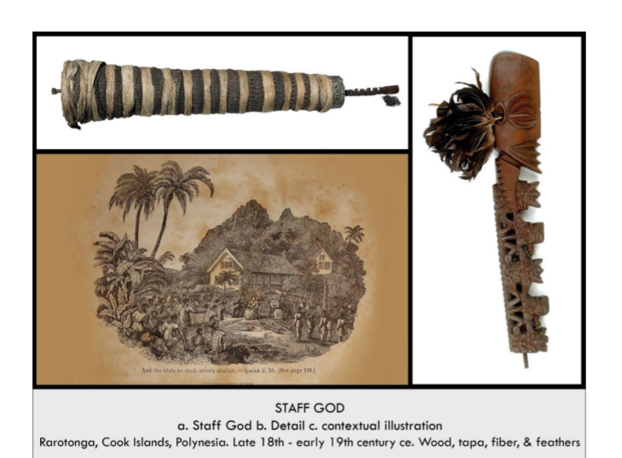

| **Form:** A carved wood, feather, tapa-cloth sculpture.  **Function:** This is figure representing a local deity.  **Content:** The work is an abstract representation of a male body. The enlarged head is 1/3 the height of the work. There are enormous eyes, a smooch, pointed forehead, and a stylized mouth. The "body" of the god resembles a spinal column & consists of 5 figures with alternating frontal && profile heads. A roll of tapa doth, often embedded wich shells and feathers representing the soul of the god, is wrapped around a central support staff.  **Context:** Staff Gods were created by the inhabitants of the Polynesian Islands & displayed on tapa-wrapped wooden shafts in village common areas. They carved these figures well into the 19th century, when Christian missionaries visited them & destroyed these "idols" as part of the local conversion process. The multiple bodies probably represent the offspring of the creator god Tangaroa & indicated his life-giving powers.  **Compare:** Effigies of Religious Deities  *-India, Shina as Nataraja*  *Japan. 7he Great Buddha, Todai-ji Temple*  **216**  The Pacific |
| --- |

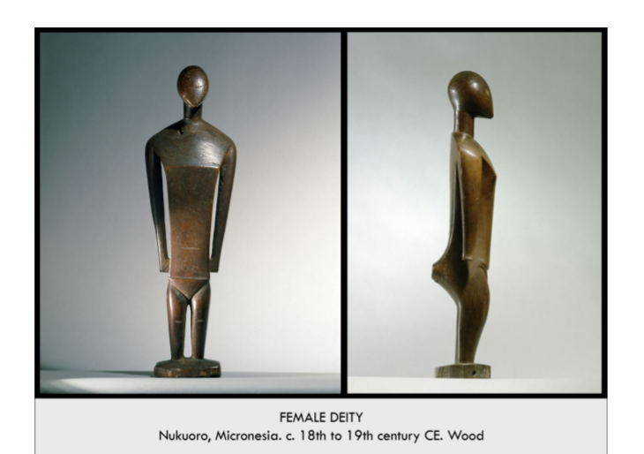

| **Form:** A carved wooden sculpture.  **Function:** This is figure representing a female diery.  **Content:** The work is an abstract representation of a female body. The pose of  The figure is alert and erect. The arms are long, and the chest is broad.  The chin of the blank face draws to a point. Horizontal lines are used  To indicate kneecaps, the navel, and the waistline.  **Context:** This is a work made by the peoples of Nukuoro in Micronesia. Local deities in Nukuoro resided in animals or were represented in stones, pieces of wood or wooden figurines such as this one. They are displayed in religious buildings belonging to the community. During festivals they are believed to be the resting location of the deities themselves.  **Compare:** Efigies of Religious Dieti;  *Oceania, Staff God, Rarotonga, Cook Islands*  *Greece, The Cult Statue of Athena, The Parthenon*  *Gochic Europe, The Rüttgen Pietà, Germany*  **217**  The Pacific |
| --- |

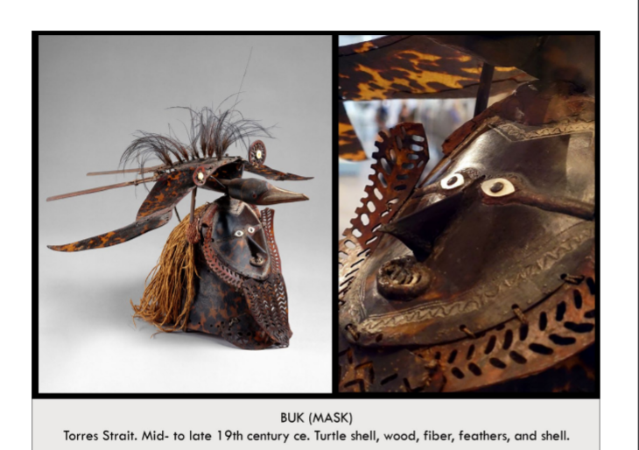

| **Form:** A turtle shell, wood, fiber,and feather mask.  **Function:** Buk masks are used with grass costumes in ceremonies about  death, fertility, or male initiation.  **Content:** The intricately carved and constructed mask shows a human face with a pointed prominent nose, white, wide-open eyes, and an open mouth. There is a stylized, pattern-pierced facial covering beside and below the face( maybe a beard). On wooden sticks above the fiber hair is a feathered pilot bird with open wings in flight.  **Context:** This is a work made by the peoples of the Torres Strait, a water passageway between Australia and New Guinea. Turtle shell masks are unique to this region. Ceremonies involving the masks feature fire, drums, and chanting. The masks often combine human and animal motifs as shown here.  **Compare:** Animal Masks with Human Faces ( masks that change you)  *Africa, Aka Elephant Mask*  *Kwakiutl (Native America), Transformation Mask*  **218**  The Pacific |
| --- |

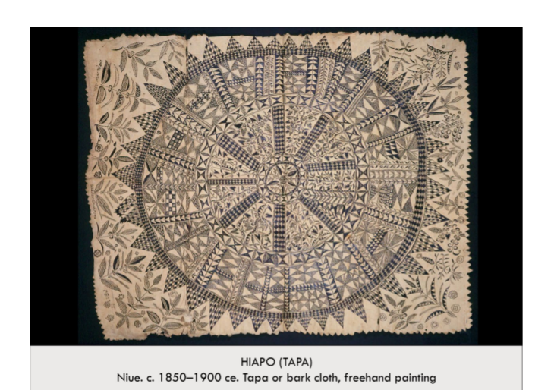

| **Form:** A pigment-painted bark doth  **Function:** Tapa fabric is traditionally worn as or used as bedding. Painted fabrics were created for ceremonial or ritual occasions. Don't know the functions or meaning ot symbols  **Content:** The work is an example of Polynesian bark cloth called tapa. The time-consuming tapa process begins with strips of mulberry trece fiber harvested by men and dried for several days. Woman strip off the  bark, soak fiber in water & pound them until flat. The strips are folded & pounded together to produce the  sheet. Finally, free-hand painting or stencils with soot or plant pigments are used to place historically-rich symbolic designs over the surface  **Context:**  Many Pacific cultures create buildings especially for the production of this cloth. Today, tapa exchanges continue at funerals, marriages and coronation ceremonies.  **Compare:** Symbolic Abstraction  *-Incan Empire, AllL-T'oqapu Tunic*  The article carpet, Islamic  **219**  The Pacific |
| --- |

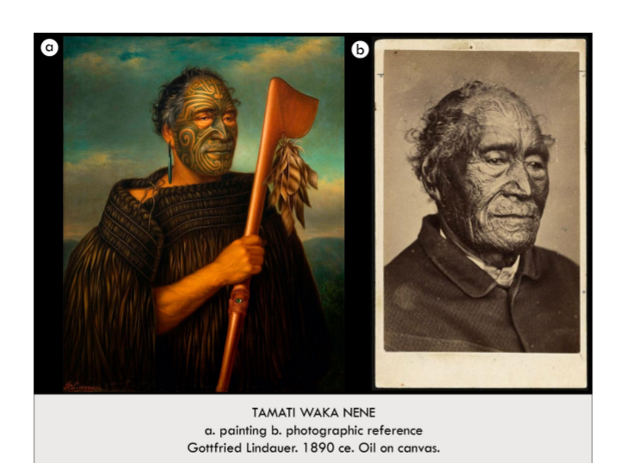

| **Form:** An oil painting on canvas.  **Function:** Portrait paintings are created for two important purposes: They record the likeness of the depicted and- if they are deceased like this example- bring their presence into the world of the living. This portrait is boch a representation of Tamati Waka Nene, it is also an embodiment of him.  **Content:** The work is a naturalistically-painted oil portrait depicting Tamati Waka Nene. Nene wears a kahu kiwi, a fine cloak covered in kiwi feathers, and an earring of greenstone or pounamu. He is holding a hand weapon known as a tewhatewha, which has feathers adorning is blade and a finely carved hand grip with an abalone or panua eye. This regalia & object mark him as man of mana or status. The most striking feature for an international audience is his intricate facial tattoo, called a mok.  **Context:** This is one of many portraits of Maori chieftains painted by the German artist Gotfried Lindauer in the late 19 century (62 of which were done for a man named Partridge who commissioned him to record the images of Maori chiefs and other important historical images from New Zealand). Lindauer based his image on a photograph taken by Joha Crombie. Mäori are the indigenous people of New Zealand. The subject of this portrait, Tamati Waka Nene, was a Rangarira or chief of the Ngäci Hao people, and an important war leader. He was probably born in the 1780s, and dicd in 1871. He lived through a time of rapid change in New Zealand, when the fist British missionaries and settlers were arriving and changing the Mäori world forever. Nene amplified the types of changes that were occurring when he converted to the Wesleyan faith and was baptized in 1839.  **Compare:** Portraits of Rulers *-Africa, Wall Plaque, Oba's Palace -Rome, Augustus of Prima Porta*  **220**  The Pacific |
| --- |

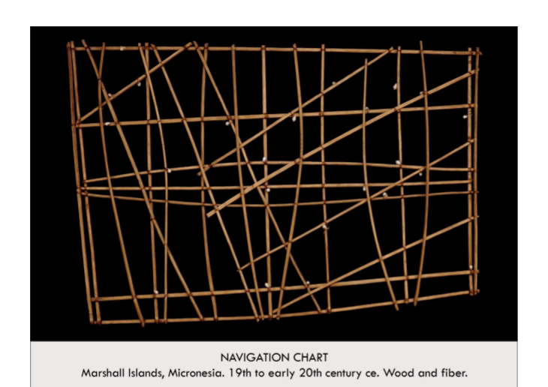

| **Form:**  wood, shell, and fiber sculpture, a piece of functional art.  **Function:**  This object is used as an aid to Memory for a sailor traveling amongst the Marshall Islands  **Content:**  The work is an abstract representation of islands (shells) amidst currents & winds (diagonal lines) on a grid of horizontal & vertical support sticks  **Context:**  Sailors in the Marshall Islands actively use or memorize these navigation charts to navigate the low-lying islands of their homeworld.  **Compare:**  Functional Art as an Aid To Memory:  Africa, Lukasa Memory board  **221**  The Pacific |
| --- |

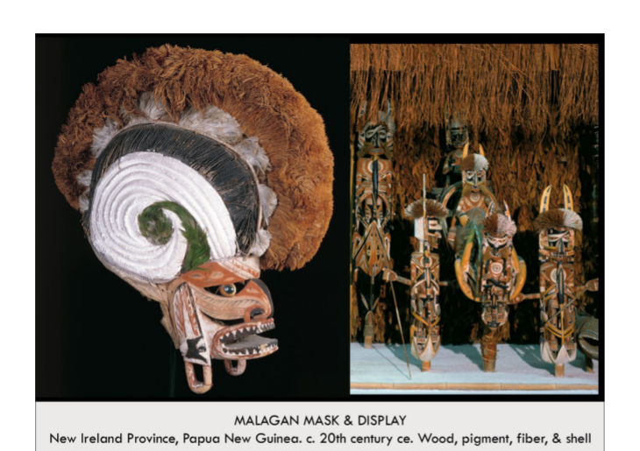

| **Form:** A wood, fiber( hair and crest of head), shel, and pigment-painted mask  **Function:** The mask is created as a representation of the spirit, or soul, of a deceased individual. The mask is worn as part of ceremony following the death of the individual whose purpose is to free the living from the obligation to serve the now-dead soul.  **Content:** This intricately carved mask is not a physical portrait but rather and abstract representation of their spirit( a persona spirit) . A large hair comb reflects hairstyles of the time. The aggressive face, angular with an open mouth and prominently painted black teeth; it also has a prominent nose and half- circle eyes, as well as striped dangling ears. Painted black. yellow, and red: important colors denoting violence, war, and magic.  **Context:** This is a work made by the peoples in Papua, New Guinea. Malagan ceremonies send the souls of the deceased on their way to the otherworld. These ceremonies begin months after the individual's death and can last many days. All structures created for the performance are allowed to rot after use. Death ceremonies  **Compare:** Faces Created to Commemorate the Dead, Masking culture( african and naive american)  *-Egypt, The Death Mask and Sarcophagus of King Tutankhamun (*made in comenorstion of dead, and a representation of the soul)  **221…2?**  The Pacific |
| --- |

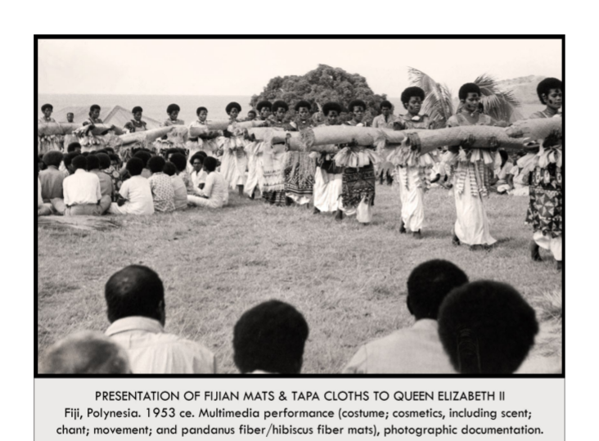

| **Form:** Multiple tapa cloths carried by the women of Fiji ina photograph from 1953 documenting a performance.  **Function:** The clochs and the performance surrounding their presentation were created to honor Queen Elizabeth II, the monarch on her visit to the British territory of Fiji in 1953.  **Content:** Tapa cloths and mats are created from the soaked and pounded bark of the mulberry tree. Men oversee the growth of the trees and women turn the bark into cloth. Clubs are used to make the bark pliable and form it into strips. The strips are glued or felted together to produce sheets. The sheets are decorated, sometimes stenciled, with local designs  **Context:** This photograph documents a performance by the Fijian people who proudly bring gifts to their monarch. Singing and dancing accompany the exchange of gifts.  **Compare:** Performance Art  *-Yayoi Kusama, Narcissus Garden, 1966*  An as a Gif  *-Africa, Mblo Mask*  **223**  The Pacific |
| --- |